## Lesson 25 – Keyring Activity Sheet

This tutorial is based upon those created by Warwick University for their STEM outreach programme and simplified.

**Step 1 Set your view to TOP**

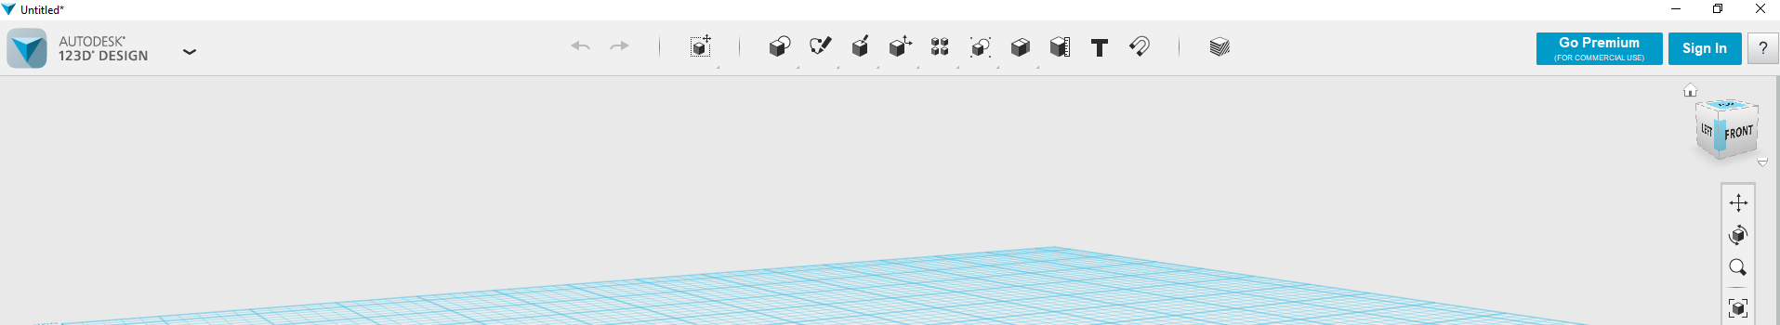

**Step 2 Draw a simple rectangle of 65 x 25mm**

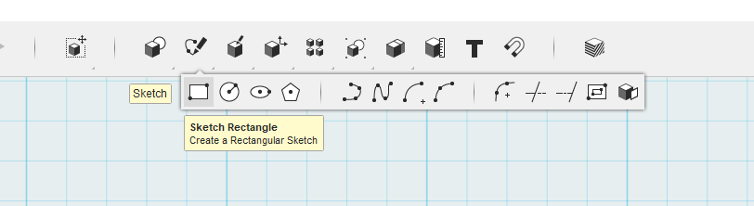

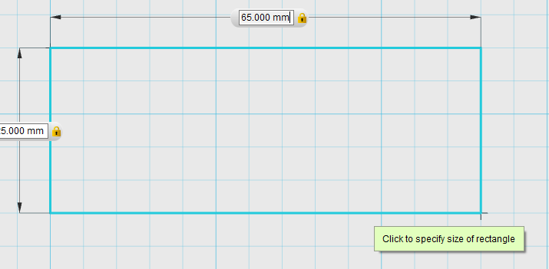

**Step 3 from the sketch menu chose fillets to curve the edges**

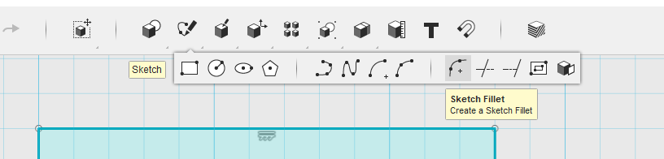

**Select the corner you wish to curve**

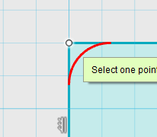

**And make the radius 6mm – do this for all 4 corners**

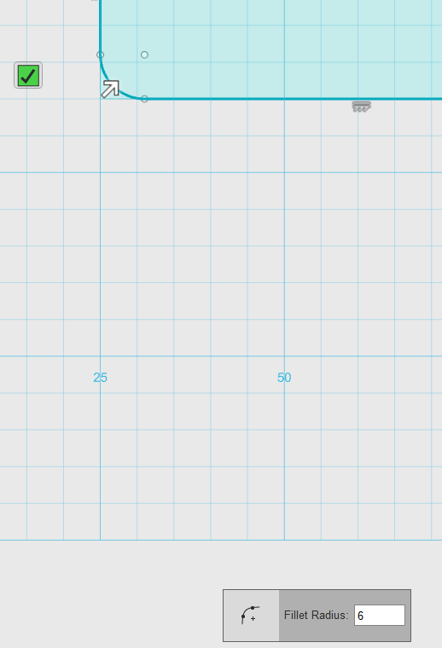

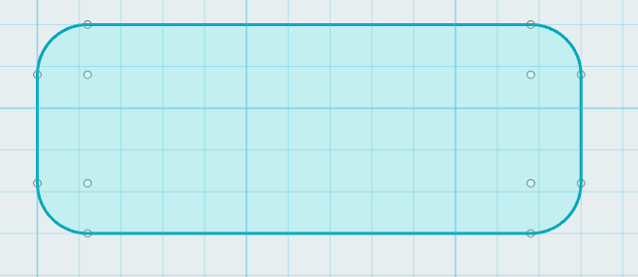

**Step 4 use CTRL C and CTRL V to make a copy of you shape**

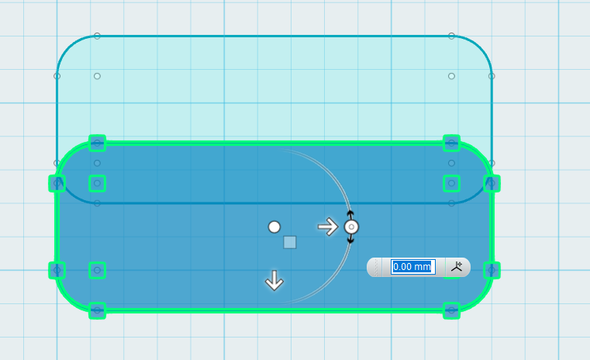

**And move it below the first**

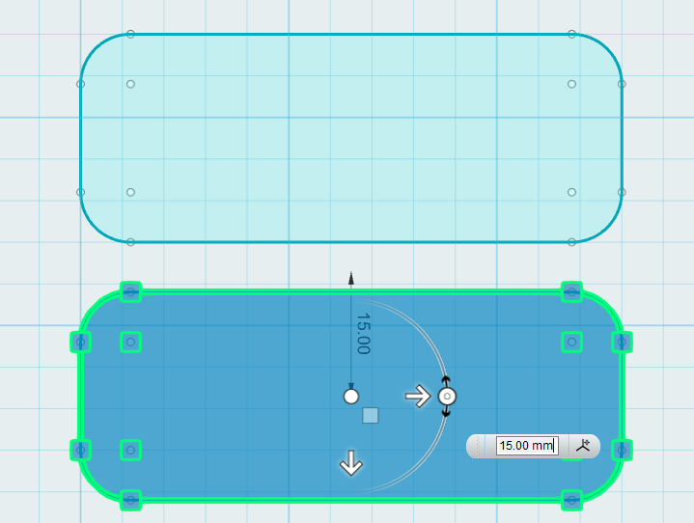

**Step 5 From the primitives option draw a 4mm circle where you want your keyring to mount**

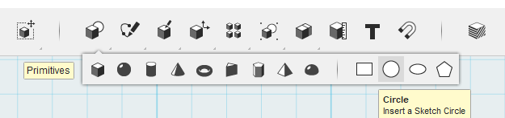

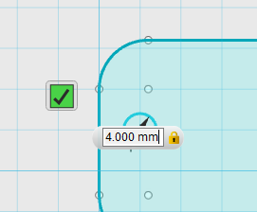

**Step 6 – From the construction menu select extrude**

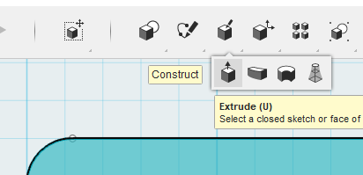

**Select the shape and extrude it 2mm up**

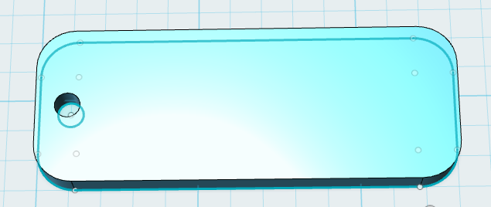

**Step 7 From the sketch menu select offset**

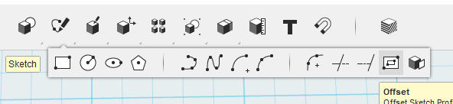

**And choose the outside edge of the bottom shape**

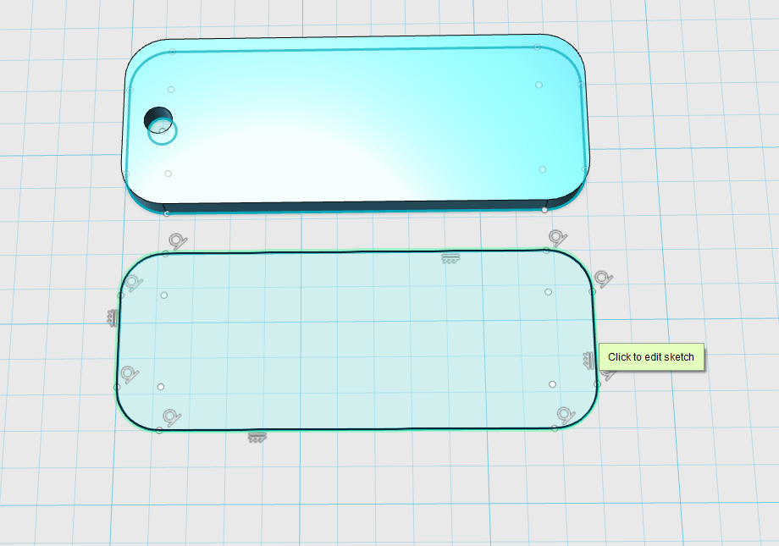

**Set the offset to 1.5mm**

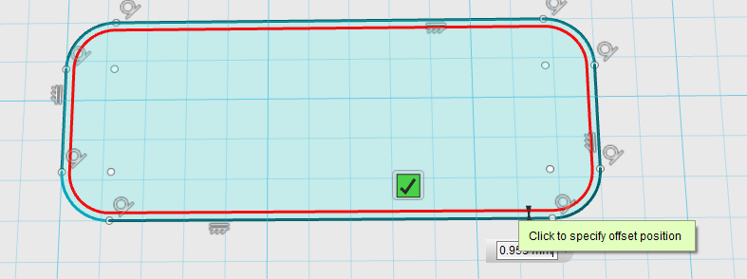

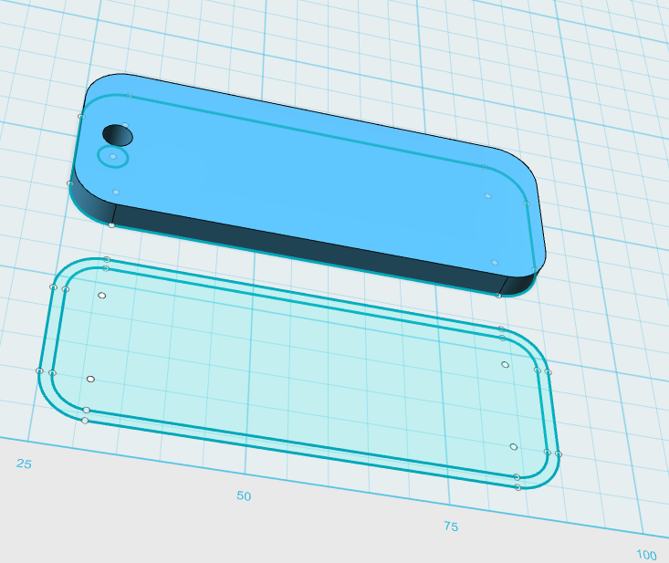

**Step 8 – Select the offset you just created and extrude it up by 1.5mm**

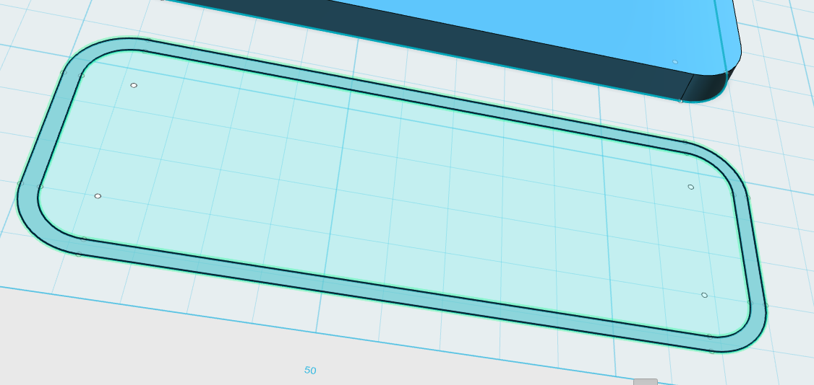

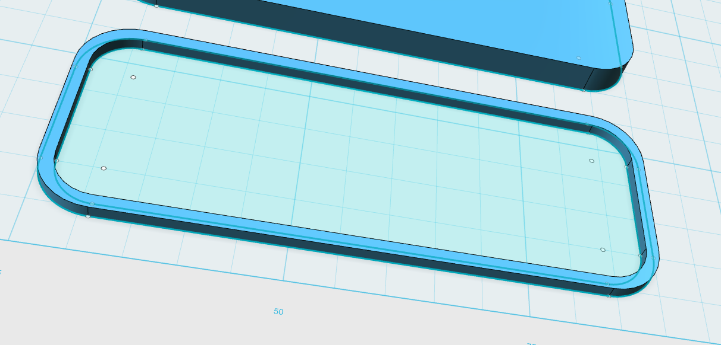

**Step 9 choose the snap tool**

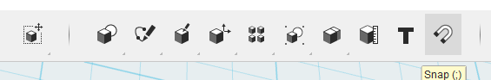

**Select your rim and then the top face to join them together**

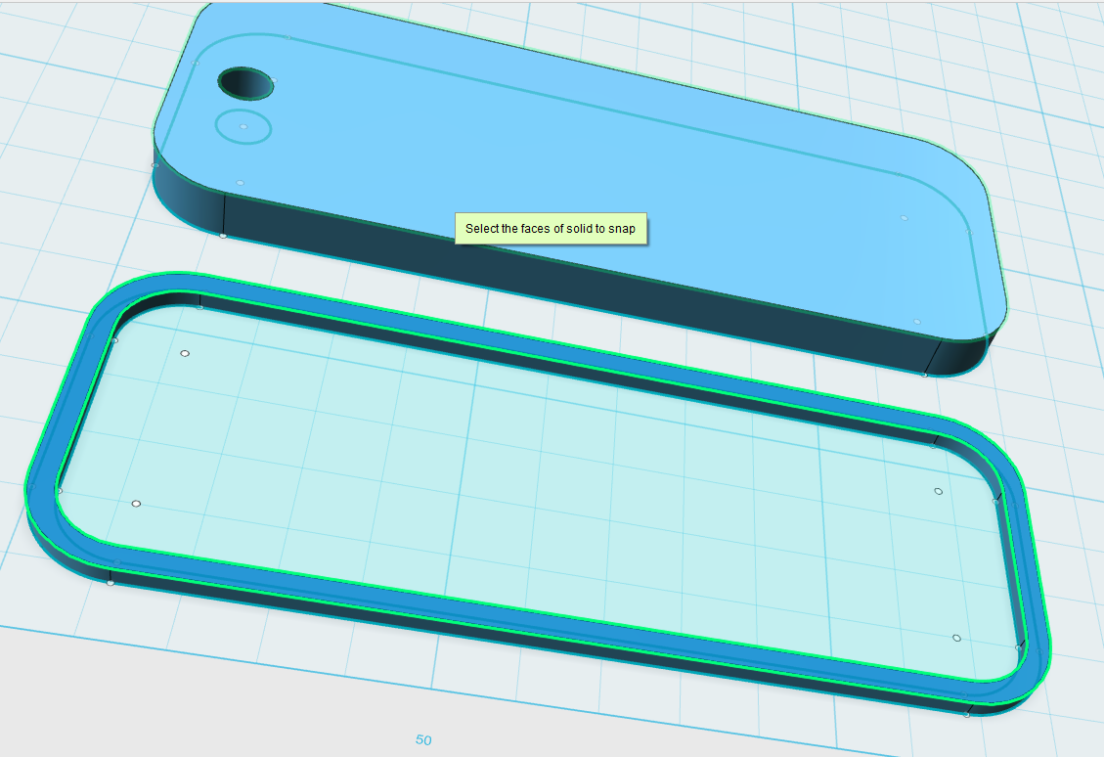

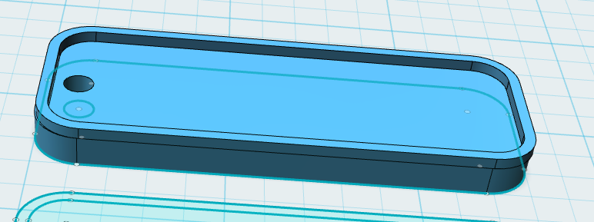

**Step 10 Choose the text option**

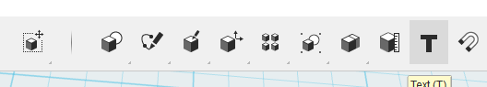

**Specify the starting point for your text**

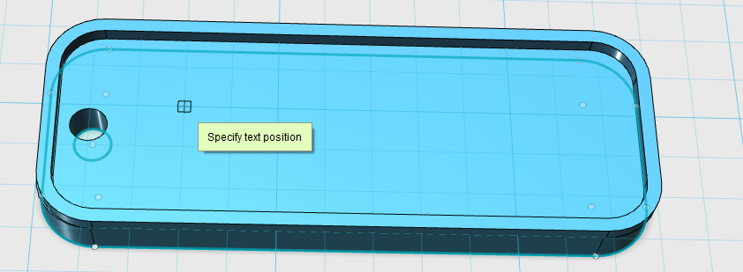

**Type, size and position before pressing OK**

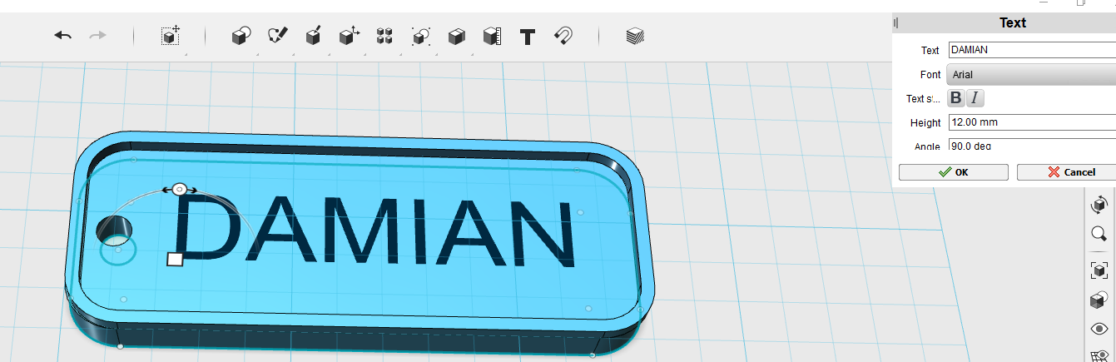

**Step 11 Select the text, click the cog and choose extrude text**

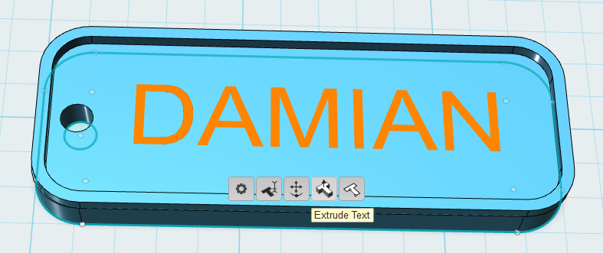

**Extrude up to 1.5mm**

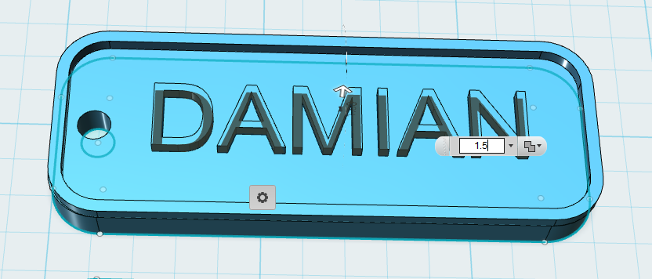

**Save your file to you PC and Export it as an STL file for printing**

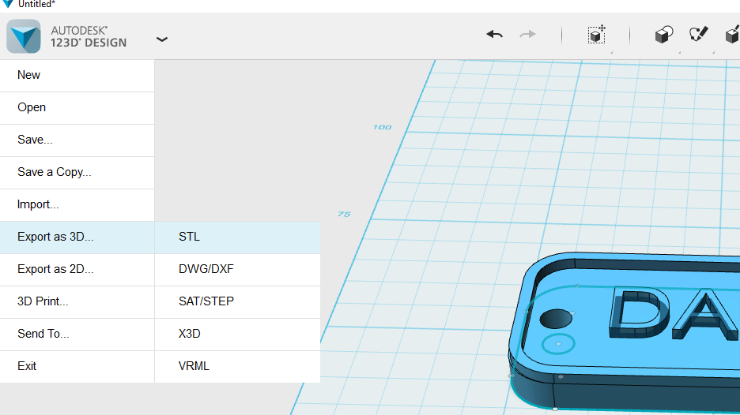

**Remember to combine the objects**

